CERAMIC STORES AND OTHER SHOPS OF BOLESŁAWIEC AND THE AREA
No. | Name, address, phone number,  web site, e-mail, coordinates | Hours of opening | Description | Legend
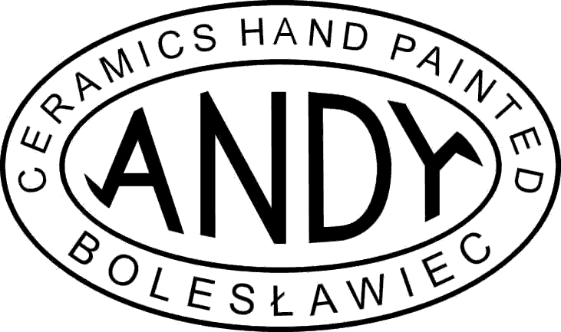  1 | ANDY  Tomaszów Bolesławiecki 111 A,  tel./ fax. 0048 75 731 0221,  www.ceramika-andy.com,  listy@ceramika-andy.com  N 51° 16.064'  E 015° 40.917' | Mo- Sat 6 am - 6 pm  Open after hours and on Sun for the guests of  the Blue Beetroot by telephone arrangement | We highly recommend Andy’s they have some really good high quality pieces with hand painted designs, at very reasonable prices.  When looking for Andy’s in Tomaszów turn LEFT at the Church- do not get confused by the Andar Signs on the right. This is a different pottery.  Andy’s pottery will give you 15% discount if you are guests of the Blue Beetroot.  Andy will even open on a Sunday by arrangement with the Blue Beetroot (just let us know). Please ask a member of staff for a discount voucher to give to Andy when you are there.  If you give him your private address (NOT an address at a military base!) and a mobile phone number, Andy can post your pottery to anywhere in Germany. | P (secured), WC,  CC, Euro, $,  CRM, E, G
2  3 | BOROWSKI’s  ART GLASS BLOWING STUDIO,  Tomaszów Bolesławiecki 87,  tel. 0048 75 738 9432,  Kasia (mob.) 0048 695 585 124  fax. 0048 75 738 9431,  www.borowski-glas.de  info@borowski-glas.de  Stan’s  ANTIQUE SHOP  UL. Kościuszki 24  59- 700 Bolesławiec  contact:  Stan’s mobile: 0048 502 90 99 95  Shop 0048 75 643 8914 | Mon- Sat 9 am- 4 pm  They sometimes can open after hours and on Sunday- by telephone arrangement form the Blue Beetroot  (if it is available, please stick to the scheduled time!)  Mon- Fri 9 am- 6 pm  Sat 8 am- 4 pm  Sun 10 am- 2 pm  Before or after the opening hours ring Stan’s mobile and ask if he could come and open the store for you | STUDIO BOROWSKI is a handmade glass blowing workshop, they only make modern art glass sculptures. Ring at the gate, they speak English and German. If you are in luck and they aren’t very busy, you may have a chance to blow your own glass ball- call one day in advance to see if it’s available. You can observe the glassblowers at work without any arrangements- notice that on Weds they work until 1pm and they always have a lunch break from 10 until 10.15am.  BOROWSKI’s Studio will also give you 10% discount if you are guests of the Blue Beetroot.  If you are interested in buying antiques this shop is a must visit!  Stan is a local character specializing in antiques. At his shops you will find old treasures and some pottery as well. He has a lot of things coming from WW2 times (military items, old books and newspapers, weapons), but also old furniture and kitchenalia.  Stan is available on his mobile 24/7 so he can open his shop for you anytime you want. | P, WC, CC, Euro, $,  Artistic Glass  E, G  P, WC, CC, Euro, $,  CRM, Antiques, GL,  E, G
4 | Cermaika Boleslawiecka „KALICH” ,  Czerna 32, 59- 730 Nowogrodziec,  tel/fax 0048 75 736 3434,  www.ceramikakalich.pl  N 51° 13.371'  E 015° 21.305' | Mon- Fr 8 am- 7 pm  Sat 5 am- 6 pm  Sun 8 am- 1 pm | This shop is well known as The „P” Shop or the Blue Shop. They have various patterns of their own production and design. They will ship orders of over 1000 $. They also do tours around their factory (for free). | P, WC, CC, Euro, $,  CRM, E, G
5 | Ceramika, Czerna 39, 0048 75 736 3310, www.ceramics.boleslawiec.org | Mon- Sat 10am- 6pm | Various pottery from different producers. | P,WC, CC, Euro, $, CRM, WKR, GL, A, G
6 | MILLENA pottery  Parzyce 108,  59- 730 Nowogrodziec  Tel. 0048 75 736 32 66  Fax. 0048 75 736 36 76  Mob: 0048 601 577 226  www.ceramikamillena.pl  admin@ceramikamillena.pl  N 51° 14.085'  E 015° 24.439' | Mon- Fri 6am- 6 pm  Sat and Sun –  10am- 6pm- after ring the mobile no. to make sure it’s open | In Parzyce village drive slow and turn right by their colorful road sign. The shop/factory is a very nice house built of yellow brick, approx 200m from the main road. They make their own body shapes and design the patterns. Prices are very reasonable (no margin). They design silver jewelry combined with Polish Pottery and are able to create an item especially for you according to your requirements. They make nice gifts and souvenirs. Millena pottery also runs ceramic workshop (email or call them 3 days in advance to see if it’s available). They can organize it for 1 up to 8 people. Highly recommended pottery. | P,WC, Euro, $,  CRM, J (silver combined with pottery), pottery combined with glass, pottery combined with wood, E, G, I
7 | ADA  Brzeźnik 60,  Tel. 0048 75 644 15 78 (after 10pm)  Mob. 0048 509 478 348  N 51° 14.918'  E 015° 28.360' | Mon- Fri 11am- 7pm  Sat 11am- 7pm | Small factory. Own designs and patterns. Christmas and Easter ornaments. Wholesale prices (no margin).  Drive about 500 m after turning off the main road along the side road. | P (lawn by the shop) WC, Euro, $, CRM
8 | Ceramika Użytkowa, A. Z. Rybak,  ul. Zgorzelecka 22 B, | --------- | This shop was known as one of  „The Three Sisters” but it is  OUT OF BUSINESS!! This shop is closed until further notice | P, CRM, Euro, $,  wooden handcraft, E, G
9 | Ceramika Artystyczna shop,  ul. Zgorzelecka 22a, 59- 700 Bolesławiec, | ------------------ | This shop was also known as one of  „The Three Sisters”, their stock is based on Ceramika Artystyczna’s pottery they also had a good assortment of unusual oriental ornaments and wicker baskets.  But it is also OUT OF BUSINESS now. This shop is closed until further notice | P, WC, CC, Euro, $, CRM, A, GL, WKR, E, G
10 | Outlet Shop of MANUFAKTURA  ul Zgorzelecka 22b,  59- 700 Bolesławiec,  tel. 0048 75 732 69 02  N 51° 15.896'  E 015° 32.961 | Mon- Sat 9 am- 5 pm  Sun 9 am- 3 pm | This store is one of Manufaktura’s Pottery shops and it only sells pottery from their factory. Unique patterns, ceramics painted by the best artists from Manufaktura Pottery. The last of the “3 sisters” left in the business.  Very nice and professional service.  -30%, -50%, - 70% discounts for outlet items | P, WC, CC, Euro, $,  CRM, GL (nice crystals and glasses),  E, G
11 | Store by Artistic Ceramic WIZA,  ul. Masarska 1, 59- 700 Bolesławiec, tel/fax 0048 75 732 56 32,  www.polishpottery.net.pl | Mo- Fr 9 am – 5 pm, Sat 9 am - 3 pm, | This shop stocks pottery from the  WIZA factory and also a nice assortment of gift items, aprons, serviettes, silver/ amber jewelry | P, WC, CC, Euro, $,  CRM, J, E, Russian
12 | HENRY’S  ul. Masarska 1, 59- 700 Bolesławiec,  tel. 0048 (0)75 732 2926  N 51° 15.885'  E 015° 33.027' | Mo- Fr 9 am - 5 pm, Sat 9 am - 5 pm | Excellent shop, good parking, with wooden handcraft and wicker goods upstairs. They also sell key-rings, t-shirts and huts with Polish emblems. Must visit. | P, CC, Euro, $,  CRM, WKR, A, E, G
13 | MANUFAKTURA Pottery  (factory and a big shop)  ul. Gdańska 30, 59- 700 Bolesławiec  tel. 0048 75 732 2062 int. 26,  Fax. 0048 75 732 6956,  www.polish-pottery.com.pl  info@polish-pottery.com.pl  N 51° 15.302'  E 015° 32.783’ | Mo- Fr 7 am - 4 pm, Sat 7 am - 3 pm | MANUFAKTURA is a large, modern pottery with an amazing mish mash of designs. Follow the circular sign with a pot in the centre.  At this pottery you can visit the factory and see how the pots are made (available 7 am- 2 pm, ticket 5zł/ 2,50zł- as the ticket you will get a special ceramic coin that you can keep). When they show you the painting process one person can try to paint a piece of pottery (sometimes more people are allowed depending on availability and how busy they are).  Here you can also take part in a ceramic workshop lessons (ask the staff for the details). | P, WC, CC, Euro, $,  CRM, CANDLES with peacock-eye pattern, ceramic jewellery, E, G, Spanish, Russian,
14 | MANUFAKTURA SHOP  ul. Kościuszki 24b,  59- 700 Bolesławiec  (opposite Artystyczna),  Tel. 0048 516 171 355  N 51° 16.380'  E 015° 34.169' | Mo - Fr 9 am - 5 pm, Sat 8 am - 4 pm  Sun 10am- 2 pm | Large selection of different patterns and shapes from Manufaktura factory. Reduced quality assortment to buy at very good prices (-30% off the normal prices). SPECIAL OFFER- ask (us or them) about the special “10 points” coupon- shopping card  HAPPY HOUR- 30% discount during the first hour of opening | P, WC, CC, Euro, $,  CRM, A (wooden handcraft), CANDLES with peacock-eye pattern, ceramic jewellery, Manufaktura Pottery T-shirts,  E, G, Spanish
15 | CERAMIKA ARTYSTYCZNA  Artistic Ceramic  ul. Kościuszki 23, 59- 700 Bolesławiec, tel. 0048 75 732 4051, Store 732 33 00, fax. 0048 75 732 4053, office,  www.ceramika-artystyczna.pl  poczta@ceramika-artystyczna.pl | Mo- Fr 9 am – 5 pm , Sat 8 am - 2 pm | The best and oldest pottery, with a world famous ceramicist, who has worked there since 1964.  High Quality products.  One Sat (10 am- 2 pm) in a month they have meetings with their designers when you can learn to paint pots (for more information- click their web site). They also do tours around the factory (for free, even for a single customer). At the store you can also buy albums and books on the Pottery and cooking books.  They do tours around the factory in English and German (form 9.30 am until 1.30pm). Periodically they do sales from -10% up to – 70% for chosen items. | P, WC, CC, Euro, $ (please note that they do not take coins and you will get the change in zlotys),  CRM, E, G
16 | CER-FAR  ul. Kościuszki 17, 59- 700 Bolesławiec  tel. 0048 75 644 32 81,  mobile 0048 607 090 625 | Mo- Fr – 8 am-6 pm  Sat – 8 am- 3 pm | Very good, big store, a lot of ceramics from all factories and rich other assortment. Good discounts. | P, WC, CC, Euro, $,  CRM, A,  E, G
17 | Zakłady Ceramiczne BOLESŁAWIEC,  ul. Kościuszki 11, 59- 700 Bolesławiec, tel. 0048 75 732 2736,  www.ceramicboleslawiec.com.pl  bol_cer@e.pl  shop’s email: sklep@ceramicboleslawiec.com.pl | Mo- Fr 7 am - 6 pm  (in winter season Dec- end of March open till 5 pm) , Sat 7 am - 3 pm  SUN 9 am- 4 pm | Big pottery with a rich selection of ceramics. You can often find bargains on the lower shelves.  They can do tours around the factory if you let them know 1 week in advance (for over 3 y.o.). They run the tours form 8.30 am until 2.30pm. Ticket costs 5 zł (approx. 1, 50 Euro). The tour takes approx 45 min and you must assemble a group of at least 10 people for it.  At this pottery you can order your pots online, and for an additional fee they can post it to EU countries, or ship it to US and Canada  Good and professional service rapping up your ceramics. | P, WC, CC, Euro, $,  CRM, E, G
18 | TYRCZ,  Ul. Kościuszki 24 B, 59- 700 Bolesławiec  Mobile phone: 0048 602 690 125 | Mo- Fri 8 am- 6 pm  Sat 8am- 4pm  Sun 10 am- 4 pm | Ceramics from a small factory run by Mr. Tyrcz. At the store by a special order you can leave a photo of yourself and they will draw a portrait. It takes approx. 3 weeks. | P, WC, CC, Euro, $,  CRM, WKR,A (portraits), crystals, Polish emblems,  E, G
19 | Store by Artistic Ceramic WIZA,  ul. Kościuszki 24, 59- 700 Bolesławiec,  tel. 0048 75 732 6975  www.polishpottery.net.pl | Mo- Fr 9 am - 5pm , Sat 9 am - 3 pm | This shop is stocked by WIZA pottery.  It is worth to visit if you look for jewelry. They have nice silvers combined with Polish ambers at very reasonable prices.  They can ship your order (no minimum order level). Discounts when paying cash.  Post office with postcards and stamps. | P, CC, Euro, $,  CRM, Jewellery, table tablecloths with pottery pattern,  A, E,
20 | CERBUD (hard to find!)  ul. Mostowa 24, 59- 700 Bolesławiec,  tel. 0048 75 734 7643 | Mo- Sat 6 am- 10 pm  Sun – by telephone arrangement | Small family business. Right after the bridge turn off the main road to the right on the dirt road Y- junction.  Their stock is functional pottery with various patterns. | P, WC,  Euro, $,  CRM, G
21 | Artistic Ceramic WIZA,  Parowa 61, 59- 724 Osiecznica  tel. 0048 75 731 2770, 0048 75 732 1822, fax: 0048 75 731 2792,  www.ceramikawiza.com  wiza@ceramikawiza.com | Mon- Fri 7 am- 3 pm  Sat 10 am- 2 pm | WIZA also in Parowa has shops elsewhere in town. Interesting patterns. It is one of the oldest potteries in the area. Was established by Mr Wiza in 1963 and been always run by the same family. Here you can also visit the factory in their opening hours. Ticket costs 5 zl (approx 1, 5 Euro) - pottery painting by special arrangement. Prices are a bit higher than the wholesale prices (small margin). | P,WC, CC, Euro, $, CRM,E
22 | BŁOTNY  Parowa 60 A, 59- 724 Osiecznica tel./ fax. 0048 75 732 1823,  www.garncarstwo7.webpark.pl  garncarstwo7@wp.pl  N 51° 21.678'  E 015° 16.803' | Mo- Fr 8 am- 3 pm  Sat 8 am- 12 pm | These two potteries produce mainly flower pots and garden ornaments but a visit there is A MUST!! The potteries maintain their old, traditional beehive kilns (as opposed to the modern tunnel kilns, used in more modern potteries). These kilns are entered through a tunnel stacked high with pots and then the entrance is bricked up and the kiln coal fired around the base. You can see the whole process and even enter the kiln, obviously before it is fired. The whole place has a Dickensian feel and is truly a living museum.  Błotny’s pottery makes nice small things like ceramic animals, flower pots and mugs. They specialize in garden pots and functional kitchen pottery. Their prices are very low. | P, WC, Euro, $,  CRM, G
23 | KOWALCZYK  Parowa 60, 59-724 Osiecznica,  tel/fax: 0048 75 731 2681  adk-parowa@adk-parowa.kki.pl | Mon- Fri 7am-2pm  Sat 7 am- 11 am
24 | WR Ceramika,  Tomaszów Bolesławiecki 99, 59- 720 Raciborowice  tel./fax. 0048 75 738 9461, | Mo- Fr 6 am-2 pm , Sat 6 am -2 pm | This pottery has nice flower and Christmas patterns  Pottery workshop for children- muddling in clay and painting bisque (you can take it home with you!). Take old clothes with you. Can be done Mon- Fri till 2 pm. Phone them 1 day in advance to arrange it. | P, WC, CC,  CRM, E,
25  26 | GALERIA MILIŃSKI,  Milinski’s Art Gallery  Pławna Dolna 9, 59- 623 Lubomierz  Tel. /fax. 0048 75 783 3280,  www.milinski.com.pl  plawna9@op.pl | Open for a whole day | GALERIA MILIŃSKI ½ hour outside town, but this eccentric artist is considered one of Poland’s best. You know you are there when you see the sculpture of giant bed in the garden. Not so long time ago Miliński opened his Museum which shows you the legends of Lower Silesia. | P, WC , A, very nice pictures by Miliński
27 | MANHATAN, by the cross of ul. Komuny Paryskiej and ul. Jeleniogorska (near the traffic lights) | Mo- Sat approx. 7 am - approx. 3 pm | Local fruit, veg and flea market. In the flea market there is a chance of finding the odd treasure. | P, WC, flee market,  fresh fruit and veg
S | SUPERMARKETS-  Tesco (open 24/7 apart from catholic and national Polish holidays- look the list below), Inter Marche, Carrefour | Open 7 days/ week from morning till evening | Inside and outside you will find ATM and money exchange. The exchange at Tesco is open every day from 9 am until 8 pm | P, WC, ATM, exchange
G | Gas station – Orlen, Shell, BP, Lotos | Open 24/7 (also during Polish holidays) | If you have diesel engine serve ON (black label tap)  Petrol (gasoline) is 95 or 98. | P, WC

Legend:
- P parking
- WC toilet
- CC credit card facilities
- Eu, $ - foreign currencies facilities
- Assortment- CRM pottery, WKR baskets & wicker products, GL glass, J jewelry, A artworks
- E English spoken, G German , F French, I Italian

How to use the map:
- The document contains 7 pages- 6 pages of the descriptions and the map
- On the map there are the main roads marked with the black lines and the stores as the small blue, red or black squares with numbers inside
- The number inside of the square corresponds with the number from the first column of the table
- In the following columns you will find all the information you need (name of the shop, its exact address, telephone number, website and email address-if they have it) , there is also the opening hour, description and at the end some very useful information telling you if the shop has a parking, toilet for their customers, will they accept credit card payments, Euro or Dollars, also what sort of assortment do they have on their stock and do they speak any foreign languages(with the explanation in the Legend above)

Important notice- please checks to see if the day(s) of your shopping are not a catholic/national Polish holiday (then all the shops are closed).
Here are a few to be aware of:
- 1st Jan, Sun – New Year
- 6th Jan, Fri - Catholic holiday
- 8th April, Sun- Easter (1st day)
- 9th April, Mon- Easter (2nd day)
- 1st May, Tues- Labour day (national holiday)
- 3rd May, Thurs- Constitution Day (National Holiday)
- 27th May, Sun- catholic holiday
- 7th June, Thurs- catholic holiday
- 15th Aug, Weds- catholic holiday
- 1st Nov, Thurs- All Saints
- 11th Nov, Sun- National Independence Day
- 25th Dec, Tues- Christmas
- 26th Dec, Weds- Boxing Day
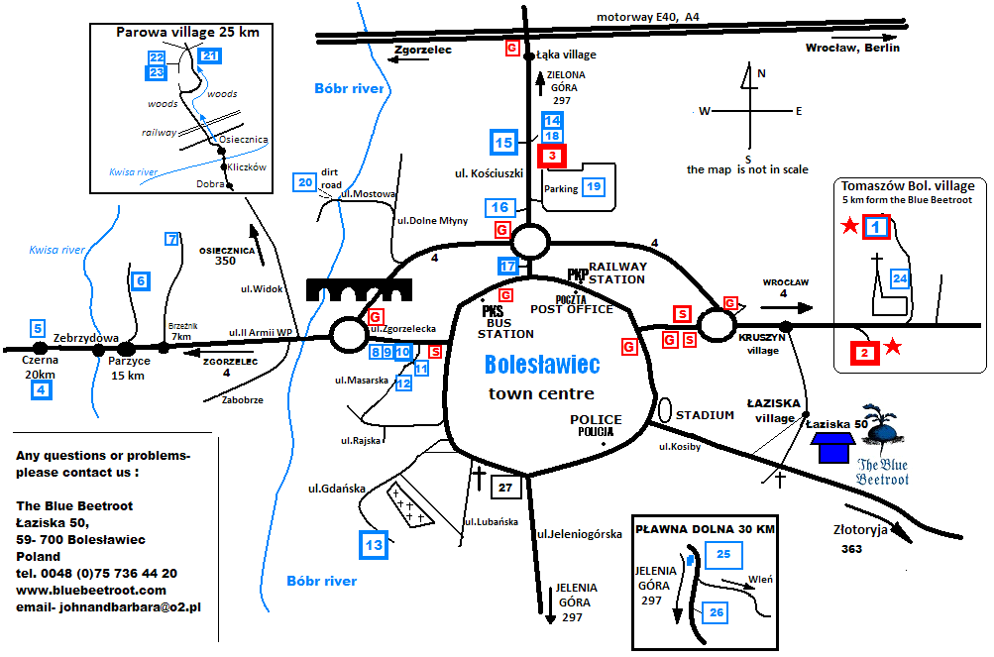

And here you can check our guests’ opinions on the best stores:
No. 1 Andy- flexible hours, discount!, great packing, unique and tasteful shapes and paint style, more artistic, DO NOT MISS- beautiful patterns, friendly, wonderful shop, they pack your pottery and can even carry it to your car! Full service
No.2 Borowski- the glass is wonderful, beautiful, bit expensive but truly unique! Great fun, very nice work, welcoming, graciously let us tour, unique styles and fascinating designs, true art.
No. 3 Stan’s antiques- friendly, maybe for those interested in military items (WW2), in a row with other shops- easy. Nice bargains if you buy more.
No. 4 Kalich- good selection, clean, large store, nice patterns. Discount depending on amount spent
No. 6 Millena- wonderful, nice patterns, beautiful, brilliant colours, do not miss! Unique work
No. 10, 13,14 all by Manufaktura- Excellent quality and selection, nice patterns, the “Happy Hour” is a good deal, but you have to stick to the 1 hour!
No. 12 Henry- Good selection of pottery and wicker. Very well organized, nice stock of wooden handcraft, ornaments and souvenirs.
No. 15 Artystyczna (Artistic Ceramic) - wonderful patterns and variety of body shapes. Large store and selection. Excellent quality.
No. 17-Zaklady- made for bus tours. Big selection, huge showroom. Good quality, traditional and innovative designs.

